**TO CREATE DEPT TABLE**

**QUERY :**

CREATE TABLE DEPT

(

DEPTNO NUMERIC(2) CONSTRAINT DEPTNO_DEPT_PK PRIMARY KEY,DNAME VARCHAR(14),LOC VARCHAR(13)

);

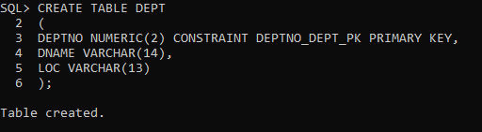

**TO INSERT DATA IN DEPT TABLE**

**QUERY :**

INSERT INTO DEPT VALUES (10,'ACCOUNTING','NEW YORK');

INSERT INTO DEPT VALUES (20,'RESEARCH','DALLAS');

INSERT INTO DEPT VALUES (30,'SALES','CHICAGO');

INSERT INTO DEPT VALUES (40,'OPERATIONS','BOSTON');

**TO CREATE EMP TABLE**

**QUERY :**

CREATE TABLE EMP

(

EMPNO NUMERIC(4) CONSTRAINT EMPNO_EMP_PK PRIMARY KEY,

ENAME VARCHAR(10),

JOB VARCHAR(9),

MGR NUMERIC(4),

HIREDATE DATE,

SAL NUMERIC(7,2),

COMM NUMERIC(7,2),

DEPTNO NUMERIC(2) CONSTRAINT DEPTNO_DEPT_FK REFERENCES DEPT(DEPTNO)

);

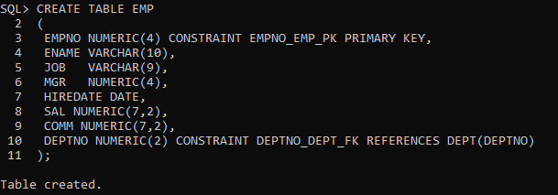

**TO INSERT DATA IN EMP TABLE**

**QUERY :**

INSERT INTO EMP VALUES (7369,'SMITH','CLERK',7902,'17-DEC-80',800,NULL,20);

INSERT INTO EMP VALUES (7499,'ALLEN','SALESMAN',7698,'20-FEB-81',1600,300,30);

INSERT INTO EMP VALUES (7521,'WARD','SALESMAN',7698,'22-FEB-81',1250,500,30);

INSERT INTO EMP VALUES (7566,'JONES','MANAGER',7839,'02-APR-81',2975,NULL,20);

INSERT INTO EMP VALUES (7654,'MARTIN','SALESMAN',7698,'28-SEP-81',1250,1400,30);

INSERT INTO EMP VALUES (7698,'BLAKE','MANAGER',7839,'01-MAY-81',2850,NULL,30);

INSERT INTO EMP VALUES (7782,'CLARK','MANAGER',7839,'09-JUN-81',2450,NULL,10);

INSERT INTO EMP VALUES (7788,'SCOTT','ANALYST',7566,'19-APR-87',3000,NULL,20);

INSERT INTO EMP VALUES (7839,'KING','PRESIDENT',NULL,'17-NOV-81',5000,NULL,10);

INSERT INTO EMP VALUES (7844,'TURNER','SALESMAN',7698,'08-SEP-81',1500,0,30);

INSERT INTO EMP VALUES (7876,'ADAMS','CLERK',7788,'23-MAY-87',1100,NULL,20);

INSERT INTO EMP VALUES (7900,'JAMES','CLERK',7698,'03-DEC-81','950',NULL,30);

INSERT INTO EMP VALUES (7902,'FORD','ANALYST',7566,'03-DEC-81',3000,NULL,20);

INSERT INTO EMP VALUES (7934,'MILLER','CLERK',7782,'23-JAN-82',1300,NULL,10);

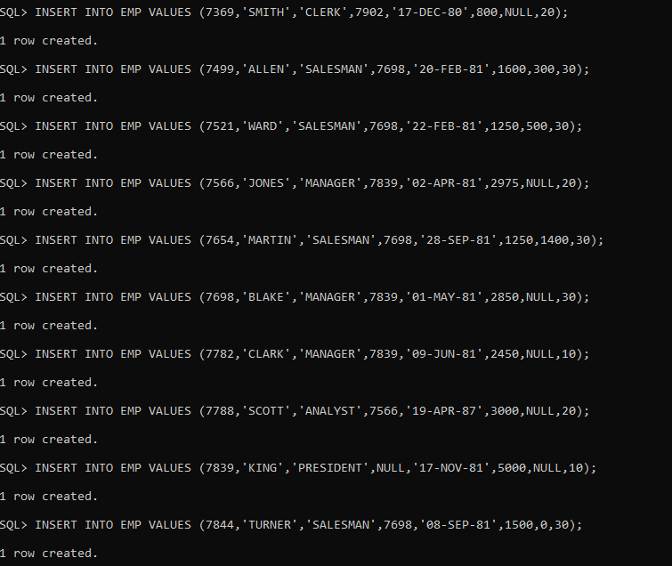

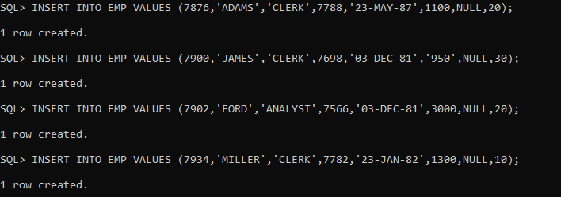

**ASSIGNMENT QUESTIONS**

11. Find all the employees whose job is either a president or manager.

**QUERY :**

SELECT * FROM EMP WHERE JOB='MANAGER' OR JOB='PRESIDENT';

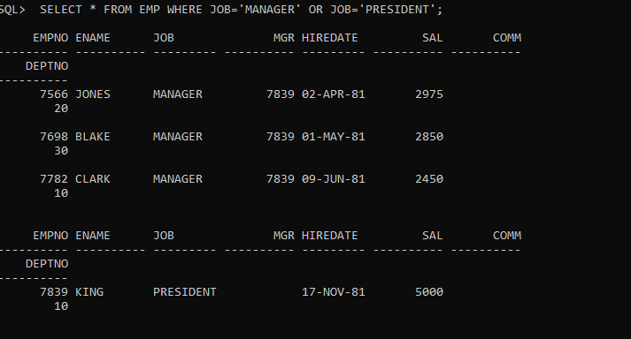

12. Find all managers who are not in dept 30.

**QUERY :**

SELECT * FROM EMP WHERE JOB='MANAGER'AND DEPTNO!=30;

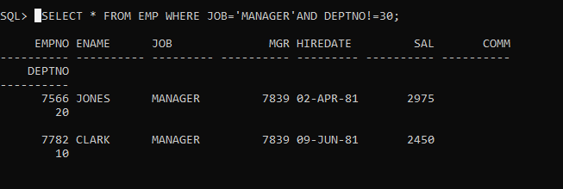

13. Find the details of all managers and clerks in dept 10.

**QUERY :**

SELECT ENAME,JOB,DEPTNO FROM EMP WHERE (JOB='MANAGER' OR JOB='CLERK') AND DEPTNO=10;

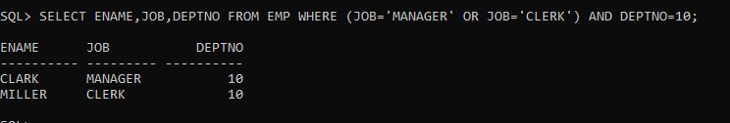

14.Find the details of all manager (in any dept) and all clerks in dept 10

**QUERY :**

SELECT ENAME,JOB,DEPTNO FROM EMP WHERE (JOB='MANAGER') OR (JOB='CLERK' AND DEPTNO=10);

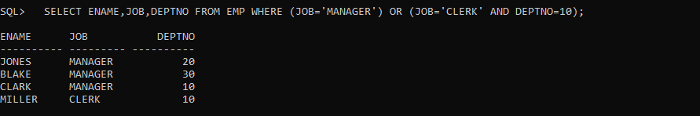

15.Find the details of all managers in dept 10 and all clerks in dept 20.

**QUERY :**

SELECT ENAME,JOB,DEPTNO FROM EMP WHERE (JOB='MANAGER' AND DEPTNO=10 ) OR (JOB='CLERK' AND DEPTNO=20);

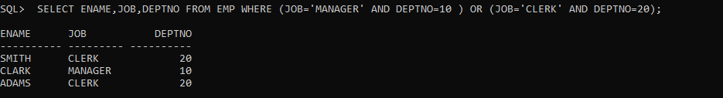

**QUERY :**

SELECT ENAME,JOB,DEPTNO FROM EMP WHERE (JOB='MANAGER' AND DEPTNO=10 ) AND (JOB='CLERK' AND DEPTNO=20);



16.Find all employees who are neither clerks nor manager but whose salary is greater than or equal to Rs. 2000.

**QUERY :**

SELECT * FROM EMP WHERE (JOB!='MANAGER'AND JOB!='CLERK') AND SAL>=2000;

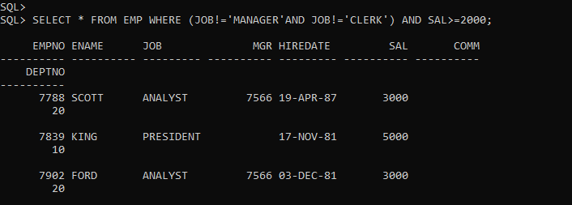

17. Find the employees who earns between Rs. 1200 and Rs.1400.

**QUERY :**

SELECT * FROM EMP WHERE SAL BETWEEN 1200 AND 1400;

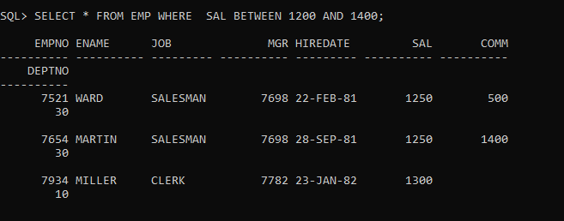

18. Find the employees who are clerks, analysts or salesman.

**QUERY :**

SELECT * FROM EMP WHERE (JOB!='MANAGER'AND JOB!='CLERK') AND SAL>=2000;

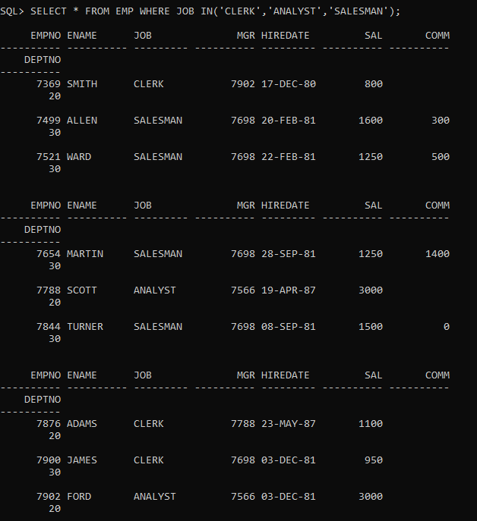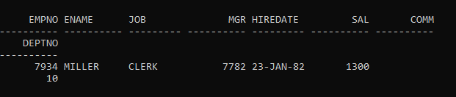

19. Find the employees who are not clerks, analyst or salesman.

**QUERY :**

SELECT * FROM EMP WHERE JOB NOT IN('CLERK','ANALYST','SALESMAN');

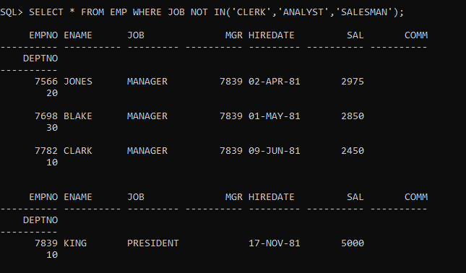

20.Find the employees who do not receive a commission i.e. commission is NULL.

**QUERY :**

SELECT ENAME ,DEPTNO FROM EMP WHERE COMM IS NULL;

